|  |
| --- |
| Ultimate Software |
| Integration PI Guidance |
| Interface Team |

|  |
| --- |
| Last Updated:  7-24-2019 |

Contents

Purpose 3

Definition 3

Why is PI important? 3

PI in the Integrations process 3

Storage Process – Google Drive File Stream 4

How to install Drive File Stream 4

Sharing Drives 7

Sharing specific files 7

Removing PI data from Google File Drive 9

Removing files from Personal Laptops 9

How to setup Task Scheduler 9

Communicating during Testing and Sharing of Issues 9

Test File Transmission 9

Other Scenarios 9

Testing Communication 9

Employee Data Issues 10

Formatting Issues 11

# Purpose

The purpose of this document provides guidance for the Integrations team to facilitate day-to-day activities for the transmission, analysis, and review of Customer employee data.

# Definition

Any information that can be used to directly or indirectly identify a person is personal information or PI. Any information used to identify, contact, locate, or relates to an individual is PI and must be safeguarded in compliance to our customer contracts and applicable privacy and data security laws. Information that is not linked to an identifiable individual or cannot be used to identify an individual might not be PI.

Company guidelines on PI can be found here: <https://ultihome.ultimatesoftware.com/static/Apps/Gecko/Cards/54198/Attachments/ISO_POL_A8.2.1_Personal_Info.pdf>

Additionally, for purposes of the Integrations team, PI includes the combination of any of the following employee data fields:

* Full SSN (EepSSN)
  + *Considered PI even if Stand Alone*
* Date of Birth (EepDateOfBirth)
* Last Name (EepNameLast)
* Full Name (EepNameFirst AND EepNameLast)
  + *Considered PI even if Stand Alone*
* Address (EepAddressLine1 OR EepAddressCity OR EepAddressState OR EepAddressZipCode)

# Why is PI important?

The Integrations must implement safeguards to ensure that customer information is legitimately and securely collected, stored, transferred, processed, and discarded in conformance with Ultimate Software (Company) policies.  Unauthorized access, use, disclosure, modification or destruction of Customer Information (such as a privacy breach), might violate law, terms and conditions of our Customer contract and Company policies. A breach might expose the Company to legal liability and loss/damage to shareholder value, our reputation and our brand.

# PI in the Integrations process

A variety of data encountered daily could include the PI fields defined above.  Within the Integrations process, PI is mostly seen within the following:

* Census files received from a Customer or Vendor
* Test files created by Ultimate Software or a Customer
* Test files created by a Vendor and sent to the Company
* Screenshots taken or received of data or file errors
* Vendor feedback reports

PI is a guideline for ‘output’ and ‘input’ type data.  Because of this, specification documents and vendor layouts do not fall under the scope of PI. PI data should only be accessed by those who have a need to know, determined by the purpose of the processing and the legitimacy of the use.

# Storage Process – Google Drive File Stream

All files containing PI data should be stored within Google Drive File Stream. Google Drive is a Company approved virtual drive that can be linked to File Explorer and easily accessed by authorized users.

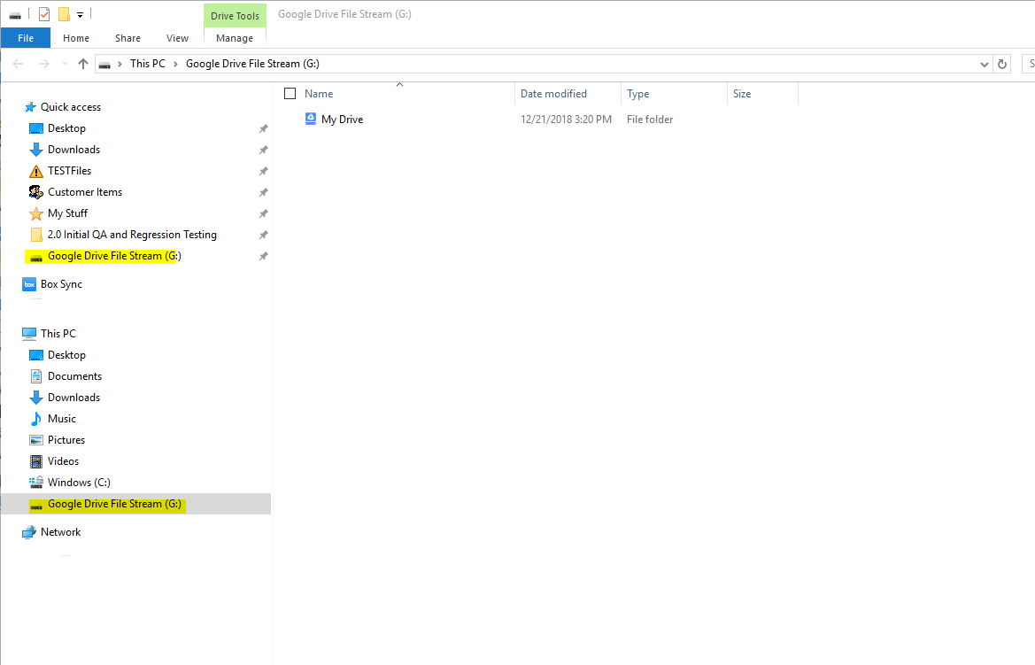

Items stored within Google Drive File Stream are not stored on the local computer but can be opened as long as the link is established.

## How to install Drive File Stream

Google Drive needs to be installed to link to File Explorer.

In a Chrome browser, go to <https://drive.google.com/drive/my-drive> and navigate to the gear icon in Google Drive on the top right of the browser.

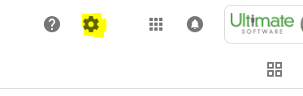

Click the gear and select Get File Drive Stream For Windows.

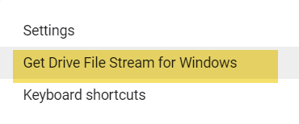

Download the Application and locate the downloaded App at the bottom of Chrome.

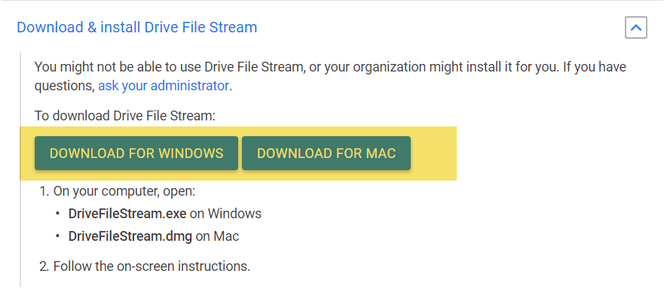

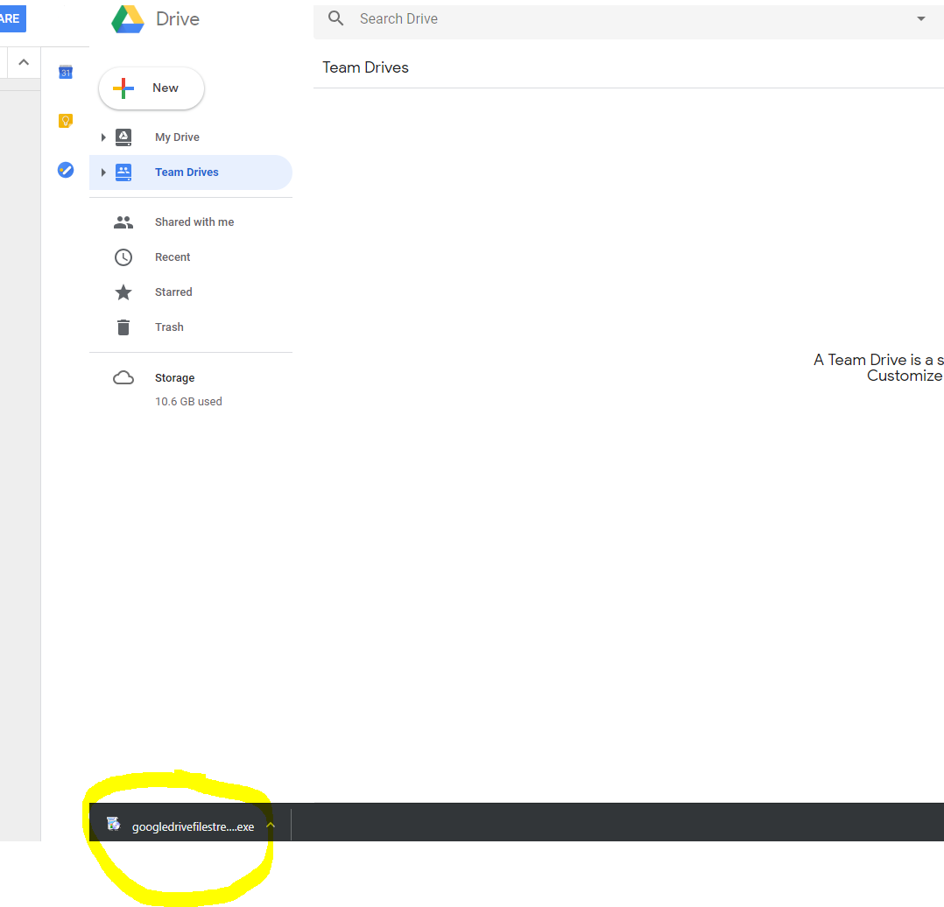

Click on the download called googledrivefilestream.exe. Click Yes on the next screen if prompted. Allow the application to install. If prompted, enter an @ultimatesoftware.com email address.

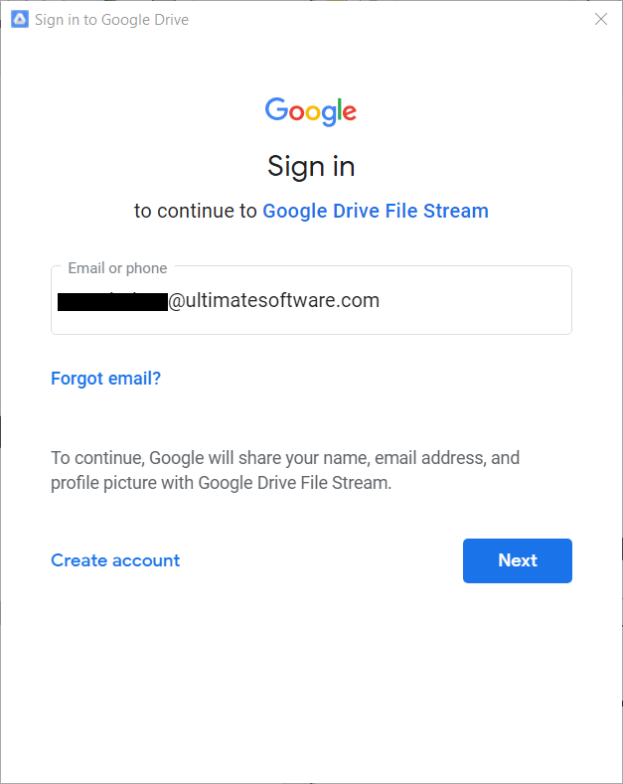

Click close after the installation is completed.

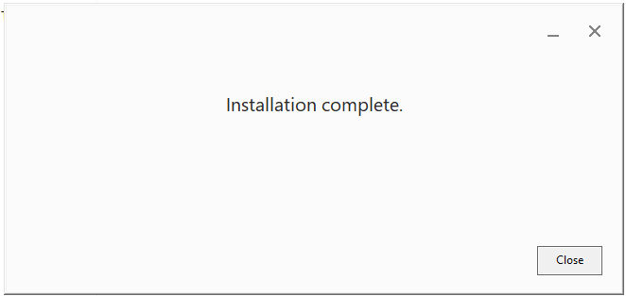

Google Drive should now appear within File Explorer.



Subfolders can be created under the MyDrive main folder.

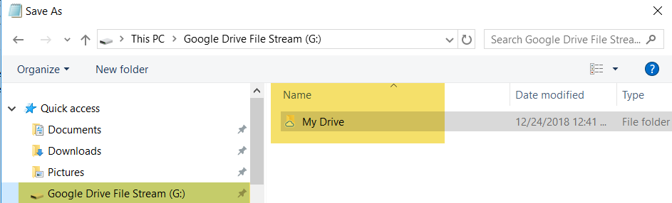

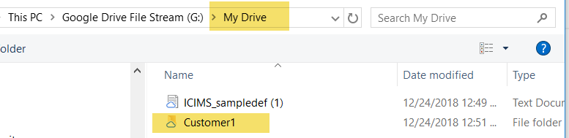

Drive can also be accessed via the Web by clicking on the icon below.

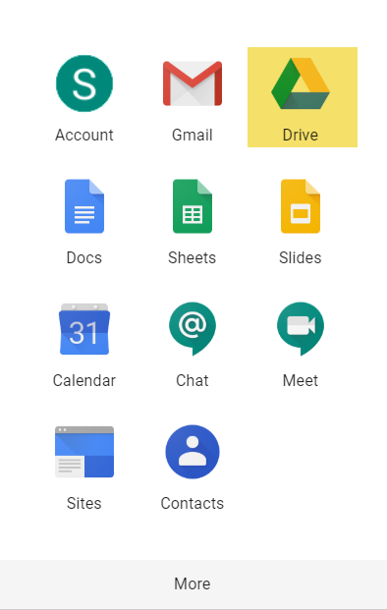

## Sharing Drives

As a general rule, PI data should stay with the person working directly on it at the time. Depending on the situation, it may be necessary to share full Customer PI data with other internal resources. Team Drives need to be created in the Web in order to assign authorized users appropriately, but can be viewed and accessed within File Explorer once they are created.

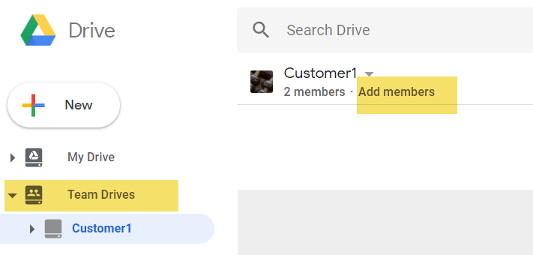

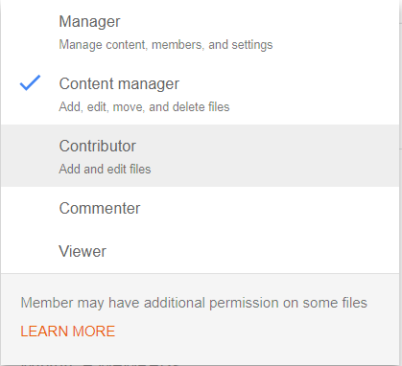

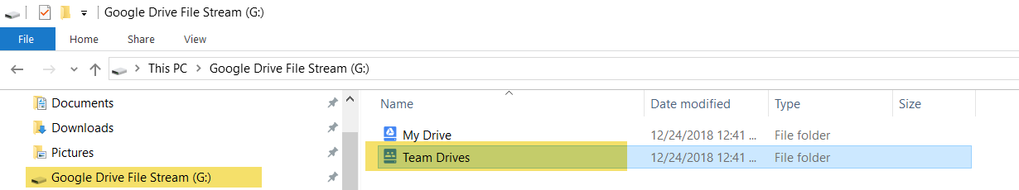

## Sharing specific files

Access can be granted to authorized users on a per file basis within Google File Drive.

Right click on the desired file and select Share.

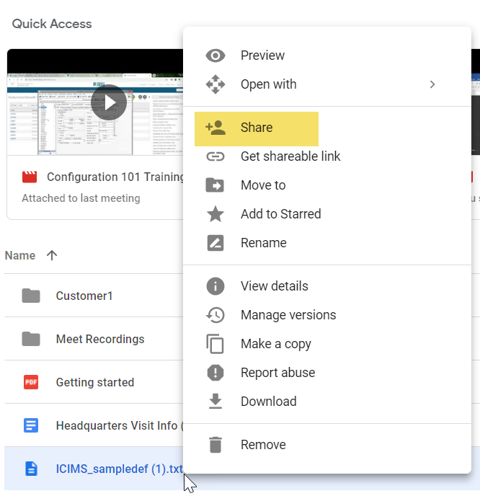

Enter in the name(s) of the authorized user(s) and modify their access level.

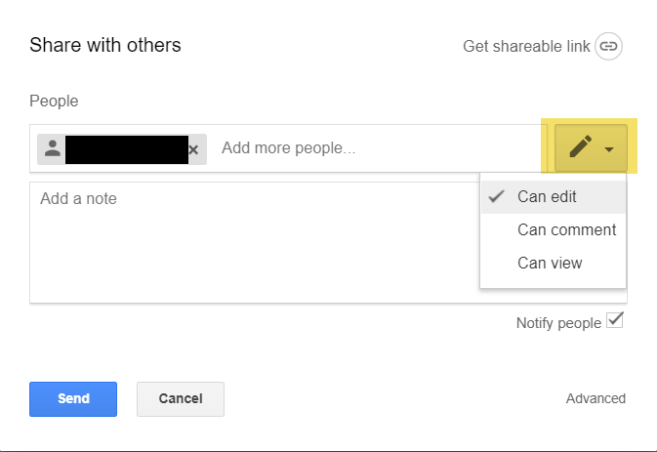

Once shared, the following icon will be visible.



Access for the file can be managed via the Advanced menu.

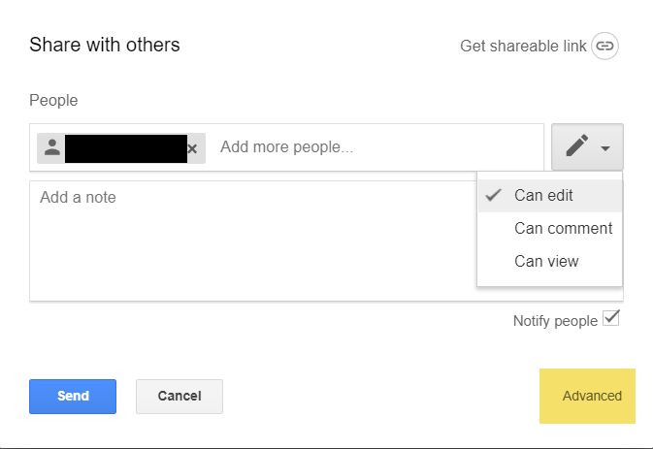

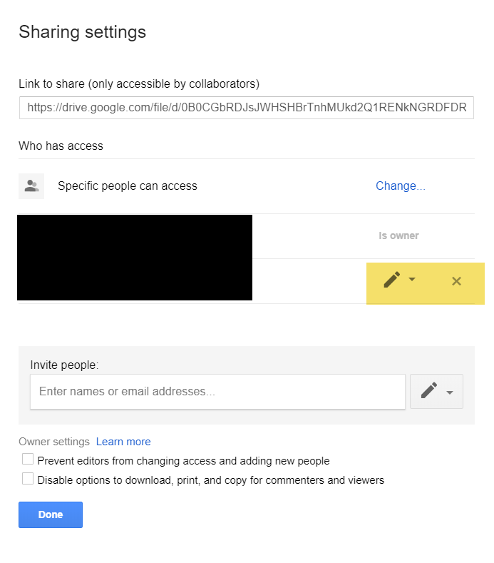

## Removing PI data from Google File Drive

PI data cannot not be stored infinitely and must only be retained until the lawful and legitimate purpose of use is achieved. As part of the Project Warranty expiration, PI files must be deleted from Drive.

# Removing files from Personal Laptops

If a file needs to be temporarily accessed on a personal laptop (C Drive), the following task scheduler script needs to be installed and run nightly to ensure proper removal of the file. With the capabilities of Google Drive, C Drive access should be minimal. The scheduler can also be used as part of data cleanup efforts.

## How to setup Task Scheduler



Communicating during Testing and Sharing of Issues

## Test File Transmission

Secure File Transfer Protocol (SFTP) is the approved approach when sending test files to external parties. If UDES is not configured when a test file needs to be sent, the assigned Transmission Consultant should be contacted to see if the transmission can be completed and utilized.

### Other Scenarios

If a Customer wants to review a file, they should be instructed to run the file on their own and view it from within their instance of UltiPro.

If a Vendor does not offer SFTP as a transmission option, the Customer can be engaged to process and send the file directly to the Vendor via email.

Ultimate Software secure email should only be used as an absolute last resort, and the reason secure email was used needs to be documented within Project Actions (as a Comment on the Action where the test file is sent).

## Testing Communication

When testing files, it is common to have to communicate between internal and external parties about specific employees. The following process defines how to best accomplish this. Documents adhering to these guidelines can be attached within Sales Force (on Project Actions or within the Project Console) or sent via Secure Email to external parties. Documents can also be placed in Drive as described above.

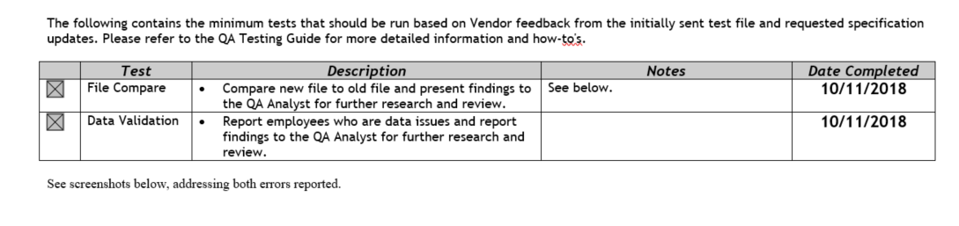

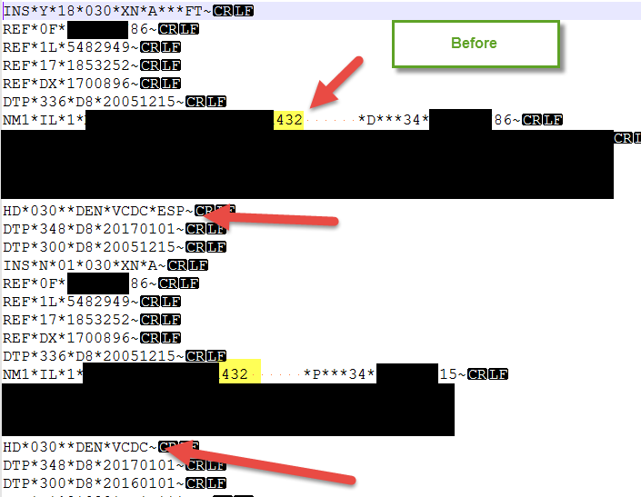 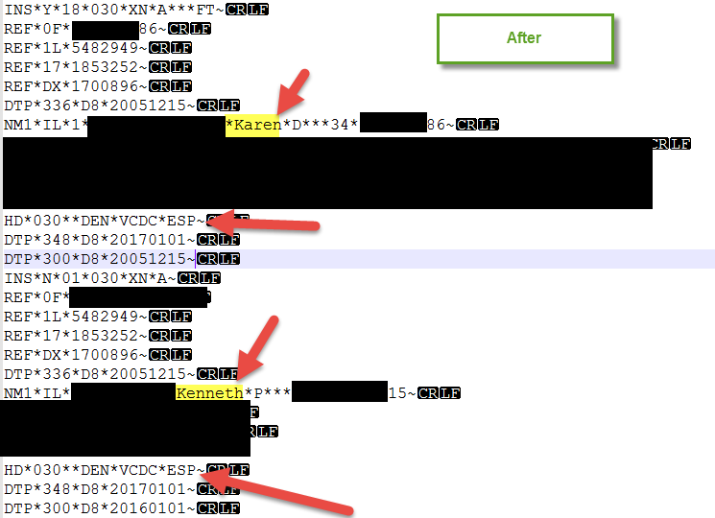

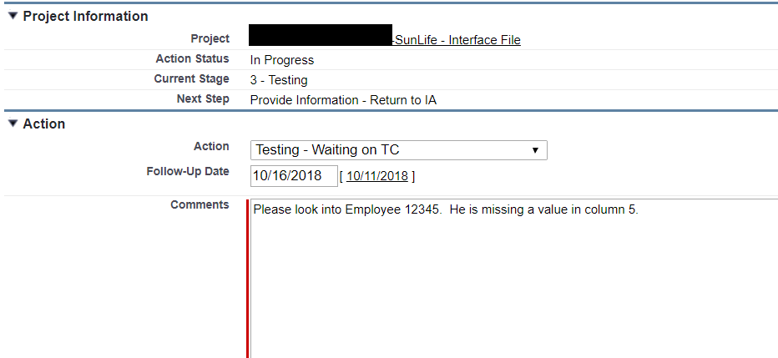

## Employee Data Issues

* If Employee Number (EecEmpNo) is available, it should be used
* If Employee Number is not available, the last for digits of the Employee SSN and/or the Employee Last Name can be used
* The field(s) in error should be notated
* All other PI needs to be blacked out

## Formatting Issues

* All PI information needs to be blacked out